SKILLWALLET – GROUP PROJECT PLAN
Project: Implement Client Script & UI Policy (Incident)
Program / Module: ServiceNow System Administrator

Project Overview
The project focuses on configuring and testing Client Scripts and UI Policies on the ServiceNow Incident table. The work is organized into sprints, epics, user stories, and story points, following the structure of the uploaded planning template.

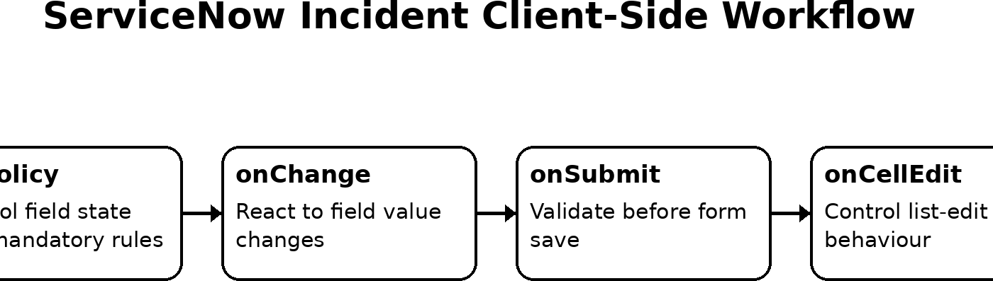

Sprint 1

Epic / Story | User Story / Milestone | Story Points
UI Policy Setup | Create UI Policy on Incident table | 2
UI Policy Setup | Create UI Policy Action for Urgency field | 2
Client Script | Create an onChange Client Script | 3
Client Script | Create an onSubmit Client Script (Save Validation) | 3
Total Story Points in Sprint 1 = 2 + 2 + 3 + 3 = 10

Sprint 2

Epic / Story | User Story / Milestone | Story Points
Client Script | Create an onCellEdit Client Script | 3
Testing & Enforcement | Test mandatory field enforcement | 2
Testing & Enforcement | Test form save validation | 2
Testing & Enforcement | Test reverse condition behaviour | 2
Testing & Enforcement | Test list-edit blocking | 2
Testing & Enforcement | Test form-based updates | 2
Total Story Points in Sprint 2 = 3 + 2 + 2 + 2 + 2 + 2 = 13

Total Story Points & Velocity
Total Story Points = 10 + 13 = 23 Number of Sprints = 2
Velocity = Total Story Points Completed / Number of Sprints = 23 / 2 = 11.5 Story Points per Sprint

Testing Plan

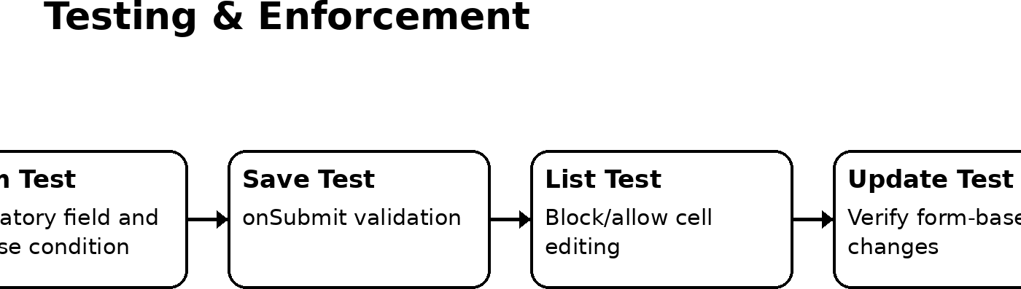

Milestone Summary
- Create the Incident UI Policy.
- Configure the UI Policy Action for the Urgency field.
- Implement the onChange Client Script.
- Implement the onSubmit Client Script for save validation.
- Implement the onCellEdit Client Script.
- Test mandatory-field enforcement, save validation, reverse conditions, list-edit blocking, and form-based updates.

Project Status
The project is currently pending team setup / project start. The next project action is to form a group using “Invite Member” or proceed individually using “Start Group Project”, after which the milestone stories can be assigned and worked through.

Note on Story Points
The uploaded template defines story points using a Fibonacci-style scale and describes 1 as very easy, 2 as normal, 3 as moderate, and 5 as difficult. The points in this adapted project plan are assigned to keep the same planning style while matching the six project milestones you provided.

Template structure used: Sprint → Epic → User Story → Story Points → Sprint Total → Overall Velocity.

